**HAND HYGIENE**

Improved healthcare hand hygiene is the highest priority area in Australia to reduce the risk of healthcare-associated infections. Epping Surgery Centre’s hand hygiene program has been developed to ensure that all staff and Credentialed Medical Practitioners are educated in the 5 moments for hand hygiene and comply with current hand hygiene practices.

Regular compliance audits are carried out and the results reviewed as part of our quality improvement processes and provided to the National Hand Hygiene Initiative for comparison to the national rate.

**Hand Hygiene Compliance Report for November 2020 – March 2021**

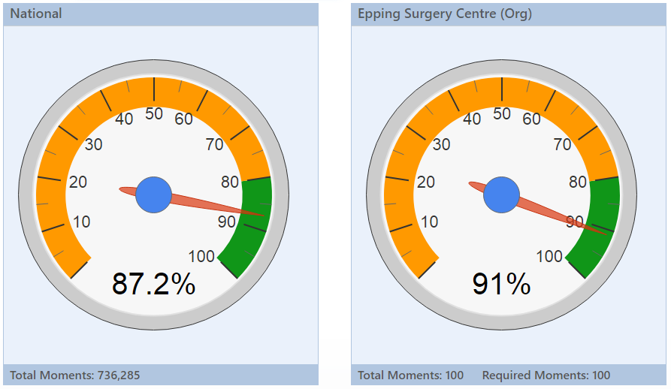

**Results as per November 2020– March 2021 Hand Hygiene Australia reporting schedule   
  
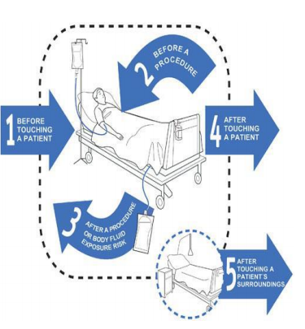Hand Hygiene Information for Patients**

Hand Hygiene is the process that reduces the number of micro-organisms on hands and is the single most important factor in reducing hospital acquired infections.

Hand hygiene is a general term applying to the use of soap/solution and water, or a waterless antimicrobial agent such as an alcohol-based hand rub, to the surface of the hands.

Improving Hand Hygiene among healthcare workers is currently the single most effective intervention to reduce the risk of hospital-acquired infections in Australian hospitals.

Five Moments for Hand Hygiene have been identified as the critical times when Hand Hygiene should be performed.